**EXP 6** 210701249

**Import Json file and do projetion, aggregation, limit,count ,skip and remove using python and hdfs.**

**Aim:**

Toimport Json file and do projetion, aggregation, limit,count ,skip and remove using python and hdfs.

**Procedure:**

**Step 1:Create json file on bash & save as emp.json**

nano emp.json ; Paste the below content on it

[

{"name": "John Doe", "age": 30, "department": "HR", "salary": 50000},

{"name": "Jane Smith", "age": 25, "department": "IT", "salary": 60000},

{"name": "Alice Johnson", "age": 35, "department": "Finance", "salary": 70000},

{"name": "Bob Brown", "age": 28, "department": "Marketing", "salary": 55000},

{"name": "Charlie Black", "age": 45, "department": "IT", "salary": 80000}

]

**Step 2:put the employees.json local directory to home/hadoop directory**

**Step 3: Install Required Packages**

Open your terminal or command prompt and run the following commands to install the required Python packages.

**pip install pandas**

**pip install hdfs**

**Step 4: Verify Installation**

Test the package installations by running the following Python commands in a Python shell or a script:

import pandas as pd

from hdfs import InsecureClient

# Check pandas version

print("Pandas version:", pd.__version__)

# Test HDFS client connection

client = InsecureClient('http://localhost:9870', user='hadoop')

print("HDFS status:", client.status('/'))

This will print the version of Pandas installed and confirm whether the HDFS connection is successful.

**Step 5: Create the process_data.py File**

Create a new Python file named process_data.py and add the following code to it:

from hdfs import InsecureClient

import pandas as pd

import json

# Connect to HDFS

hdfs_client = InsecureClient('http://localhost:9870', user='hdfs')

# Read JSON data from HDFS

try:

with hdfs_client.read('/home/hadoop/emp.json', encoding='utf-8') as reader:

json_data = reader.read() # Read the raw data as a string

if not json_data.strip(): # Check if data is empty

raise ValueError("The JSON file is empty.")

print(f"Raw JSON Data: {json_data[:1000]}") # Print first 1000 characters for debugging

data = json.loads(json_data) # Load the JSON data

except json.JSONDecodeError as e:

print(f"JSON Decode Error: {e}")

exit(1)

except Exception as e:

print(f"Error reading or parsing JSON data: {e}")

exit(1)

# Convert JSON data to DataFrame

try:

df = pd.DataFrame(data)

except ValueError as e:

print(f"Error converting JSON data to DataFrame: {e}")

exit(1)

# Projection: Select only 'name' and 'salary' columns

projected_df = df[['name', 'salary']]

# Aggregation: Calculate total salary

total_salary = df['salary'].sum()

# Count: Number of employees earning more than 50000

high_earners_count = df[df['salary'] > 50000].shape[0]

# Limit: Get the top 5 highest earners

top_5_earners = df.nlargest(5, 'salary')

# Skip: Skip the first 2 employees

skipped_df = df.iloc[2:]

# Remove: Remove employees from a specific department

filtered_df = df[df['department'] != 'IT']

# Save the filtered result back to HDFS

filtered_json = filtered_df.to_json(orient='records')

try:

with hdfs_client.write('/home/hadoop/filtered_employees.json', encoding='utf-8', overwrite=True) as writer:

writer.write(filtered_json)

print("Filtered JSON file saved successfully.")

except Exception as e:

print(f"Error saving filtered JSON data: {e}")

exit(1)

# Print results

print(f"Projection: Select only name and salary columns")

print(f"{projected_df}")

print(f"Aggregation: Calculate total salary")

print(f"Total Salary: {total_salary}")

print(f"# Count: Number of employees earning more than 50000")

print(f"Number of High Earners (>50000): {high_earners_count}")

print(f"Top 5 Earners: \n{top_5_earners}")

print(f"Skipped DataFrame (First 2 rows skipped): \n{skipped_df}")

print(f"Filtered DataFrame (IT department removed): \n{filtered_df}")

**Step 6:Run the process_data.py Script**

Run the script in your terminal or command prompt by typing the following command:

**python3 process_data.py**

Make sure your HDFS is up and running, and the /home/hadoop/emp.json file exists on your HDFS.

The script will read the JSON file from HDFS, process the data, and save the filtered results back to HDFS.

**Step 7: Check the output.**

**OUTPUT:**

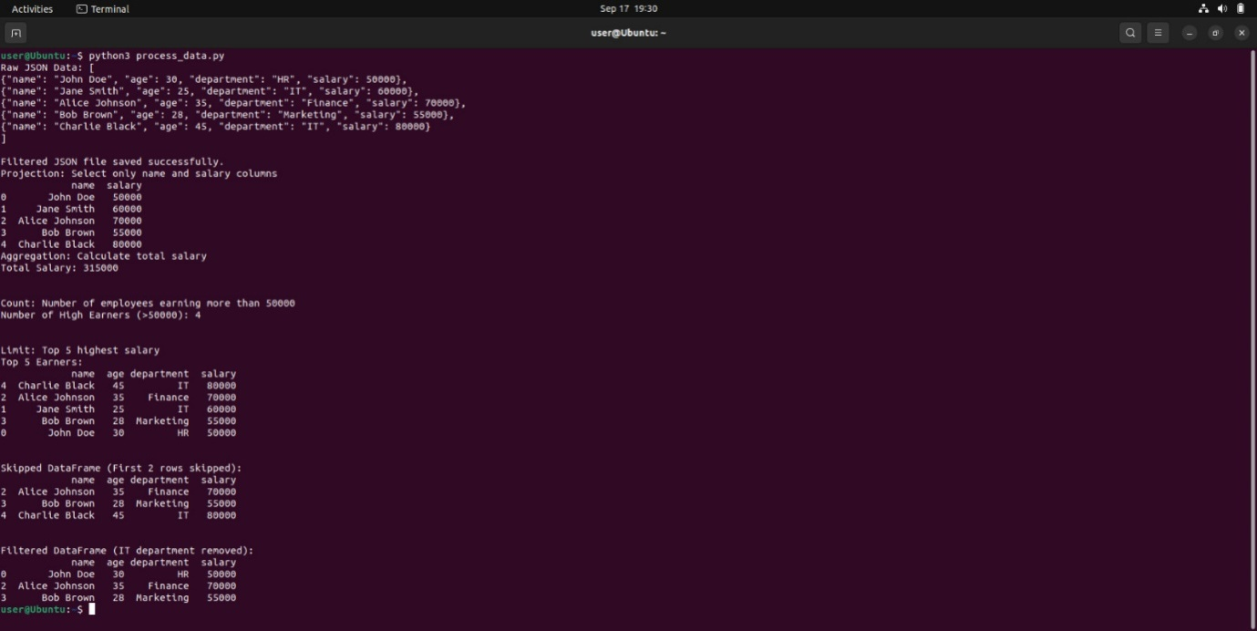

**Result:**

Thus the program toimport Json file and to do projetion, aggregation, limit,count ,skip and remove using python and hdfs is executed successfully.